Annual Notification of Benefit Rights

2023 Medicare Part D Notice of Creditable Coverage

Important Notice from Premier Talent Partners
About Your Prescription Drug Coverage and Medicare

Please read this notice carefully and keep it where you can find it. This notice has information about your current prescription drug coverage with Premier Talent Partners and about your options under Medicare’s prescription drug coverage. This information can help you decide whether or not you want to join a Medicare drug plan. If you are considering joining, you should compare your current coverage, including which drugs are covered at what cost, with the coverage and costs of the plans offering Medicare prescription drug coverage in your area. Information about where you can get help to make decisions about your prescription drug coverage is at the end of this notice.

There are two important things you need to know about your current coverage and Medicare’s prescription drug coverage:

1. Medicare prescription drug coverage became available in 2006 to everyone with Medicare. You can get this coverage if you join a Medicare Prescription Drug Plan or join a Medicare Advantage Plan (like an HMO or PPO) that offers prescription drug coverage. All Medicare drug plans provide at least a standard level of coverage set by Medicare. Some plans may also offer more coverage for a higher monthly premium.

2. Premier Talent Partners has determined that the prescription drug coverage offered by the Premier Staffing Inc Health and Welfare Plan is, on average for all plan participants, expected to pay out as much as standard Medicare prescription drug coverage pays and is therefore considered Creditable Coverage. Because your existing coverage is Creditable Coverage, you can keep this coverage and not pay a higher premium (a penalty) if you later decide to join a Medicare drug plan.

When Can You Join A Medicare Drug Plan?

You can join a Medicare drug plan when you first become eligible for Medicare and each year from October 15th to December 7th.

However, if you lose your current creditable prescription drug coverage, through no fault of your own, you will also be eligible for a two (2) month Special Enrollment Period (SEP) to join a Medicare drug plan.

What Happens To Your Current Coverage If You Decide to Join A Medicare Drug Plan?

If you decide to join a Medicare drug plan, your current Premier Talent Partners coverage may be affected.

If you do decide to join a Medicare drug plan and drop your current Premier Talent Partners coverage, be aware that you and your dependents will not be able to get this coverage back until the plan’s next open enrollment period.

When Will You Pay A Higher Premium (Penalty) To Join A Medicare Drug Plan?

You should also know that if you drop or lose your current coverage with Premier Talent Partners and don’t join a Medicare drug plan within 63 continuous days after your current coverage ends, you may pay a higher premium (a penalty) to join a Medicare drug plan later.

If you go 63 continuous days or longer without creditable prescription drug coverage, your monthly premium may go up by at least 1% of the Medicare base beneficiary premium per month for every month that you did not have that coverage. For example, if you go nineteen months without creditable coverage, your premium may consistently be at least 19% higher than the Medicare base beneficiary premium. You may have to pay this higher premium (a penalty) as long as you have Medicare prescription drug coverage. In addition, you may have to wait until the following October to join.

For More Information About This Notice Or Your Current Prescription Drug Coverage…

Contact the number listed below for further information. NOTE: You’ll get this notice each year. You will also get it before the next period you can join a Medicare drug plan, and if this coverage through Premier Talent Partners changes. You also may request a copy of this notice at any time.

For More Information About Your Options Under Medicare Prescription Drug Coverage…

More detailed information about Medicare plans that offer prescription drug coverage is in the “Medicare & You” handbook. You’ll get a copy of the handbook in the mail every year from Medicare. You may also be contacted directly by Medicare drug plans.

For more information about Medicare prescription drug coverage:
• Visit www.medicare.gov
• Call your State Health Insurance Assistance Program (see the inside back cover of your copy of the “Medicare & You” handbook for their telephone number) for personalized help
• Call 1-800-MEDICARE (1-800-633-4227). TTY users should call 1-877-486-2048.

If you have limited income and resources, extra help paying for Medicare prescription drug coverage is available. For information about this extra help, visit Social Security on the web at www.socialsecurity.gov, or call them at 1-800-772-1213 (TTY 1-800-325-0778).

Remember: Keep this Creditable Coverage notice. If you decide to join one of the Medicare drug plans, you may be required to provide a copy of this notice when you join to show whether or not you have maintained creditable coverage and, therefore, whether or not you are required to pay a higher premium (a penalty).

For more information, contact the HR Department.

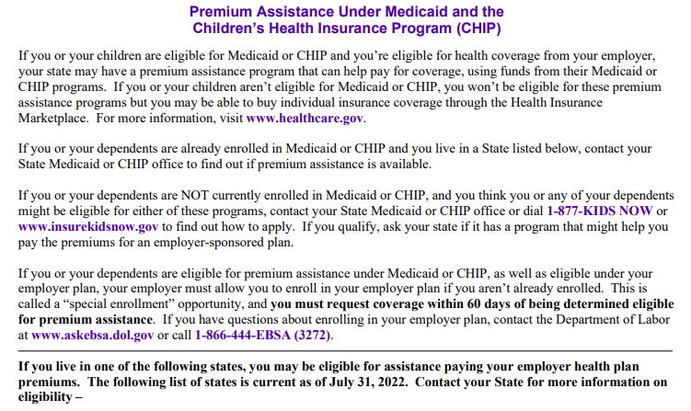
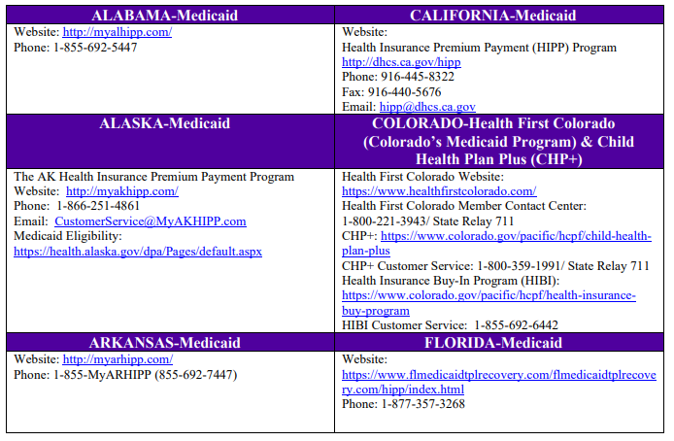
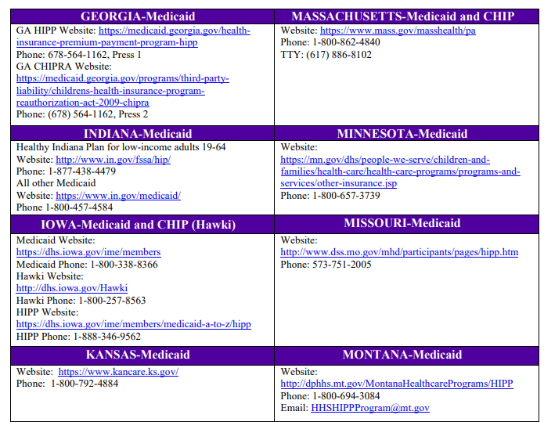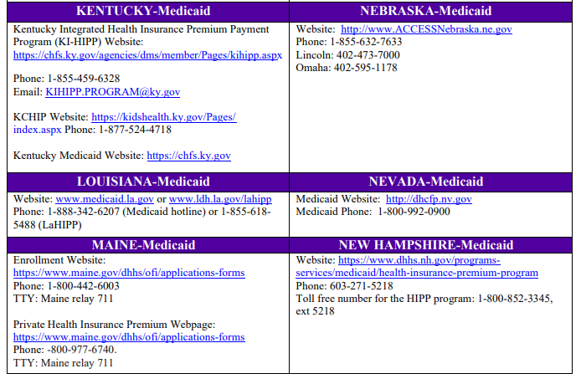
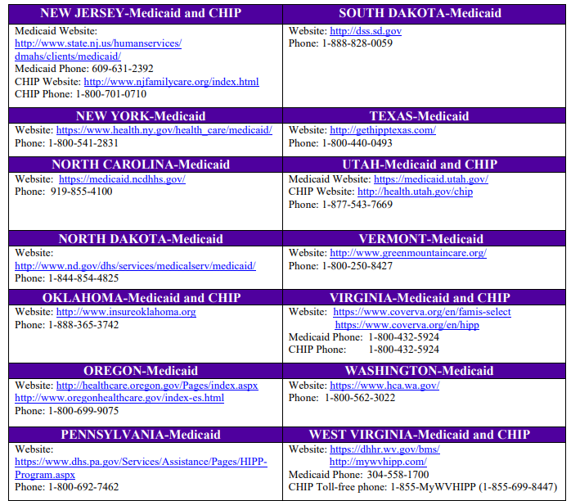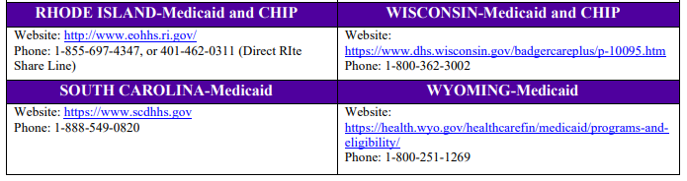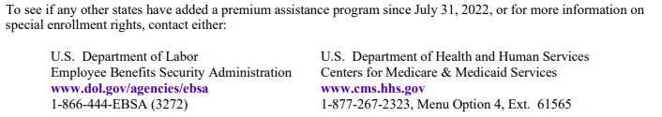

Women's Health and Cancer Rights Act (WHCRA)
If you have had or are going to have a mastectomy, you may be entitled to certain benefits under the Women’s Health and Cancer Rights Act of 1998 (WHCRA). For individuals receiving mastectomy-related benefits, coverage will be provided in a manner determined in consultation with the attending physician and patient, for:
- Reconstruction of the breast on which the mastectomy has been performed;
- Surgery and reconstruction of the other breast to produce a symmetrical appearance; and
- Prostheses and physical complications for all stages of a mastectomy, including Lymphedemas (swelling associated with the removal of lymph nodes).
These benefits may be subject to annual deductibles and coinsurance provisions that are appropriate and consistent with other benefits under your plan or coverage. If you would like more information on WHCRA benefits, contact the HR Department.

Notice of HIPAA Enrollment Rights
If you are declining enrollment for yourself or your dependents (including your spouse) because of other health insurance coverage or group health plan coverage, you may be able to enroll yourself and your dependents in this plan if you or your dependents lose eligibility for that other coverage (or if the employer stops contributing toward your or your dependents’ other coverage). However, you must request enrollment within 30 days after your or your dependents’ other coverage ends (or after the employer stops contributing toward the other coverage).
In addition, if you have a new dependent as a result of marriage, birth, adoption, or placement for adoption, you may be able to enroll yourself and your dependents. However, you must request enrollment within 30 days after the marriage, birth, adoption, or placement for adoption.
To request special enrollment or obtain more information, contact the HR Department.

Patient Protections Notice
If a qualifying benefit option under a group health plan maintained by the employer generally requires or allows the designation of a primary care provider, the covered individual has the right to designate any primary care provider who participates in the Plan’s network and who is available to accept the covered individual. Until the covered individual makes this designation, the Plan may designate a primary care provider for him or her. For children, the covered employee or spouse may designate a pediatrician as the primary care provider. For information on how to select a primary care provider, and for a list of the participating primary care providers, contact the HR Department.
For any qualifying benefit option, covered individuals do not need prior authorization from the group health plan or from any other person (including a primary care provider) in order to obtain access to obstetrical or gynecological care from a health care professional in the Plan’s network who specializes in obstetrics or gynecology. The health care professional, however, may be required to comply with certain procedures, including obtaining prior authorization for certain services, following a pre-approved treatment plan, or procedures for making referrals. For a list of participating health care professionals who specialize in obstetrics or gynecology, contact the HR Department.
ADA Notice Regarding Wellness Program
The company’s wellness program is a voluntary wellness program available to all employees. The program is administered according to federal rules permitting employer-sponsored wellness programs that seek to improve employee health or prevent disease, including the Americans with Disabilities Act of 1990, the Genetic Information Nondiscrimination Act of 2008, and the Health Insurance Portability and Accountability Act, as applicable, among others. If you choose to participate in the wellness program you may be asked to complete a voluntary health risk assessment or "HRA" that asks a series of questions about your health-related activities and behaviors and whether you have or had certain medical conditions (e.g., cancer, diabetes, or heart disease). You may also be asked to complete a biometric screening, which may include a blood test. If so, you are not required to complete the HRA or to participate in the blood test or other medical examinations.
However, employees who choose to participate in the wellness program may receive an incentive. Although you are not required to complete the HRA or participate in the biometric screening (if any), the program may provide that only employees who do so will receive the incentive.
Additional incentives of up to 30% of the cost of coverage may be available for employees who participate in certain health-related activities or achieve certain health outcomes. If you are unable to participate in any of the health-related activities or achieve any of the health outcomes required to earn an incentive, you may be entitled to a reasonable accommodation or an alternative standard. You may request a reasonable accommodation or an alternative standard by contacting the HR Department.
The information from your HRA and the results from your biometric screening (if any) will be used to provide you with information to help you understand your current health and potential risks, and may also be used to offer you services through the wellness program. You also are encouraged to share your results or concerns with your own doctor.

Protections from Disclosure of Medical Information
We are required by law to maintain the privacy and security of your personally identifiable health information. Although the wellness program and the employer may use aggregate information it collects to design a program based on identified health risks in the workplace, the wellness program will never disclose any of your personal information either publicly or to the employer, except as necessary to respond to a request from you for a reasonable accommodation needed to participate in the wellness program, or as expressly permitted by law. Medical information that personally identifies you that is provided in connection with the wellness program will not be provided to your supervisors or managers and may never be used to make decisions regarding your employment.
Your health information will not be sold, exchanged, transferred, or otherwise disclosed except to the extent permitted by law to carry out specific activities related to the wellness program, and you will not be asked or required to waive the confidentiality of your health information as a condition of participating in the wellness program or receiving an incentive. Anyone who receives your information for purposes of providing you services as part of the wellness program will abide by the same confidentiality requirements. Only individuals necessary to administer the program will receive your personally identifiable health information in order to provide you with services under the wellness program.
In addition, all medical information obtained through the wellness program will be maintained separate from your personnel records, information stored electronically will be encrypted, and no information you provide as part of the wellness program will be used in making any employment decision. Appropriate precautions will be taken to avoid any data breach, and in the event a data breach occurs involving information you provide in connection with the wellness program, we will notify you immediately.
You may not be discriminated against in employment because of the medical information you provide as part of participating in the wellness program, nor may you be subjected to retaliation if you choose not to participate.
If you have questions or concerns regarding this notice, or about protections against discrimination and retaliation, please contact the HR Department.

